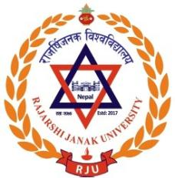 | Research Center  Rajarshi Janak Univrsity
Registration Form
Article Writing Workshop for Undergraduate Students of Rajarshi Janak University (June 15-20, 2025)
Name of the participant:

Faculty:

Program:

Semester:

Mobile No.:

Email:

Note: To register send the filled Form to research@rju.edu.np with the Subject: AWW2025. The schedule will be provided on 14th of June, 2025.

